Physical Robot and Raspberry Pi

## Setting up the Raspberry Pi

With the beginning of the sprint, we needed to first set up our hardware and CPUs.

In the beginning we first worked on setting up the RaspberryPi, figuring out how the motor shield works and how the Arduino should be programmed. While trying to set up the RaspberryPi we encountered multiple challenges, the most important two being that: we did not have wired peripherals or a wired network to setup the RaspberryPi in order to get the first SSH session on the RaspberryPi. We tried to overcome these issues in several ways, at /first we tried to write the dhcpcd.conf (<https://wiki.archlinux.org/title/dhcpcd>) to configure the Raspberry Pi to assign itself a static IP address on the Ethernet port. This way we could get a SSH session on the Pi, and then install Zerotier (for networking) and connect it to the TU/e wifi using one of our passwords. However we learned that in raspbian the dhcpcd.conf only gets created and read after raspi-config has run once, and since a network was never found it never completes. This leaded to the static IP not being configured, not allowing us to connect over wired networking (without setting up a DHCP server). After a couple of hours we figured this out and reinstalled the raspbian with the WiFi credentials of a mobile hotspot of one of the team members. Then we were able to connect to it over wifi, and using information found on the TU/e Linux Wiki, install Zerotier and continue setting up the Raspberry Pi.

## ESPcams

Because we selected the ESPcam cameras we needed to set up a 2.4Ghz wifi hotspot. We originally chose to set it up on the Raspberry Pi (mainly to minimize latency). After reading information about the programs we had to use for this (dhcpcd, hostapcd and dnsmasq), and configuring them I was able to set up a Wifi hotspot on the Raspberry Pi. I assigned static DHCP leases for the ESP-cams and everything worked perfectly (to be continued :) ) The config files of the Raspberry Pi  that I wrote can be found on Github. <https://github.com/Tim455/DBL_group_22/tree/main/Pi_config_files>

Setting up the ESPcams was quite easy. We quickly selected a firmware to upload to the camera, the specific firmware was selected because it included a versatile configuration interface and because it included different ways of getting an image from the camera. This was mainly because we wanted to be sure that if one of the ways had, for example, an unexpected delay we would continue the project without having to reupload another sketch to the ESPcam.

Uploading a sketch to the ESPcam’s was quite a hassle. This was mainly because we did not have a proper 3.3V TTL-usb adapter. At first we tried to use the usb-TTL chip on the Arduino Uno while connecting the main Atmel chip of the Arduino to ground to prevent us from accidently programming the Arduino instead of the ESPcam. This however did not work for unknown reasons. Our theory was that this did not properly work because the TTL chip is designed for 5V instead of 3.3V. When we tried to use the TTL adapter on one of the NodeMCU boards we had more success, after having the wires the wrong way around, and discovering that the ESPcams need to be put into program mode with a special jumper wire, we were able to read the serial of one of the ESPcams. We are now able to upload the proper firmware to the ESPcams using esptool.py and connect it to the hotspot on the Pi.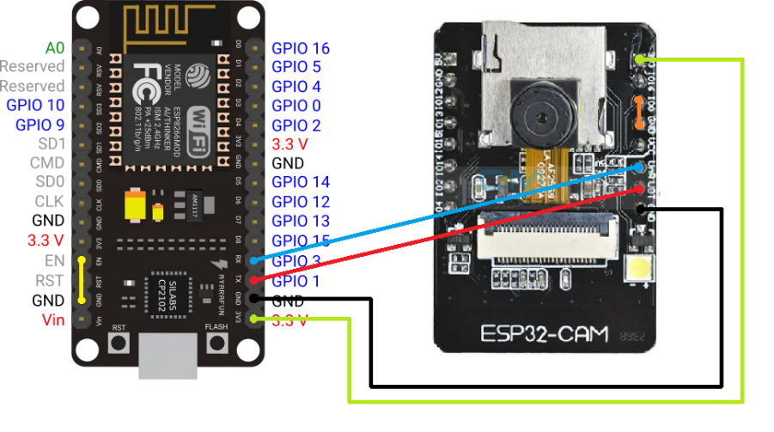

Viewing the webpage from the ESPcams on our laptops was quite problematic because we wanted to connect to the hotspot of the Raspberry Pi and browse the internet at the same time. While we could configure the Raspberry Pi to also IPv4 packets I was not able to set it up after several hours of trying and because of frequent reboots I was keeping back the team. However I was able to set up the Raspberry Pi to connect to the ESPcams and my laptop to the Raspberry Pi, so in theory something should be possible. After a while I learned that I was able to use SSH in addition to a socks proxy to connect to get the Raspberry Pi to forward my requests from my laptop.

After we could set up a remote SSH with the RaspberryPi, we proceeded to explore the possibilities of input and output operations of the Arduino relating to Servo motors and the sensors we had on hand, mainly phototransistors. While the Arduino IDE is the norm for such projects, since we decided on measuring test coverage, we needed an integrated development environment that had the option of debugging. For this purpose we implemented the professional development environment Platform IO as the tool to feed and process code and instructions to the Arduino in the initial testing state.

## Arduino

After our hardware and programming environment had been set up, we could proceed to elementary testing of the different parts in possession, and what they were capable of. We began with researching and utilizing the official documentation and materials of the Arduino company at [arduino.cc](http://arduino.cc) as guides for wiring and elementary coding. With the aforementioned aid we were successfully able to periodically and recursively rotate the servo motor in our inventory.

Riding this initial success we proceeded on to the task of reading differences in the environment through a phototransistor. After the proper research we were able to correctly wire the phototransistor, set the Arduino to print the value of the analog pin connected to it, and monitor if there were changes in the value as the lighting changed. We discovered that the change in lighting is indeed reflected in the values printed, and we decided we can use it as an elementary object detection system by placing an LED against it and noting the change induced by something coming between the two.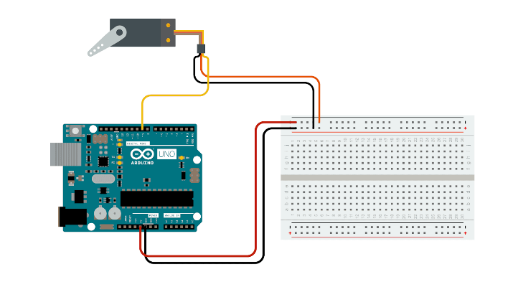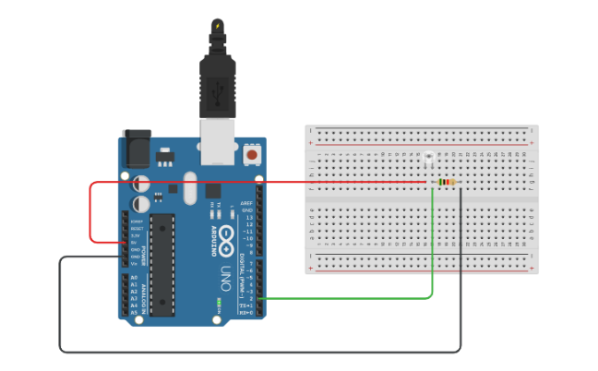

## General Programming Architecture

We designed the general programming architecture of the robot. We made a working model (programming and physical robot) of part of the robot that would sense the disk and push it to the lower part of the robot for processing.

Having previously programmed the Arduino with the sensor and servo motor, we quickly discovered a major issue with the system if we were to connect all needed parts to one Arduino, mainly the inability to carry out simultaneous protocols of different parts. To achieve this in accordance with the other actuators and sensors, we decided we could control different parts by different Arduinos. To do this, we used a RaspberryPi, that would control the Arduinos and receive data from them over serial connection.



## Communication between the Raspberry Pi and the Arduino

We used the PySerial library to send data to the Arduinos. We developed protocols to respond to the commands, so that the Arduinos can act accordingly.

Then, we developed the control logic: When the light sensor reads a value that indicates that there is a disk coming, the Arduino sends that to the RaspberryPi. Then, if the robot is allowed to process the disk, the RaspberryPi sends the command to push the disk. So, the servo motor controlling the push spins from 180 to 0 and pushes the disk and goes back to its initial position.

## First version of the upper part of the robot

The mechanical part of the ‘upper’ robot consists of the light sensor (phototransistor), a LED light opposite of it, the pushing arm, and the robot frame. The LED is switched and it normally lights in the direction of the phototransistor, without any obstacles. So, normally the light sensor reads a relatively constant value. When a disk moves past the sensor, the light from the LED is blocked, and thus the reading of the light sensor increases. If the read value becomes significantly high, the disk is detected. When a disk is first sensed, the work of the robot is put on hold for as much time as it takes for the disk to pass (so that the same disk is not detected twice). For the pushing arm, we used a servo motor and mechanical wheels and rods to create the linear movement of the arm. The reason we decided on a pushing arm rather than a normal gate is to be able to isolate a single object at a time, for easier programming of the cameras and general logic of the robot. This arm will be in such an M shape, where even if there are two objects directly behind each other, the arm will be able to displace only the frontal object, and the tailing one would remain on the belt , ramming into a flat barrier of the arm for a part of the second, which should realistically not cause it to fall. In addition, we used the belt we made last week to test the robot.

Note: The actual upper part of the robot will have 2 light sensors, we simply did not have enough parts to implement this.

## WiFi issues

During this week we also had a lot of issues with the WiFi hotspot of the Raspberry Pi disappearing and extremely high latency spikes (~500 ms). Because of this we decided to use a purpose built hotspot instead of the custom Raspberry Pi one. After browsing our options we decided on a GL.iNet GL-MT300N-V2 because it had all the features we needed and supported extending the TU/e wifi network. After we bought, and installed it we managed to make the WiFi network work without any issues.

## Programming of the motors and sensors

During this week, we began designing and programming the “lower”part of the robot as well as the slingshot part. We used a separate microcontroller that would control the two servo motors (used to sort the disk), a light sensor, and a stepper motor (for the slingshot). The “lower” part of the robot utilizes the belt we made in the first week.

## Control logic and state machine

The control logic is as follows:

The light sensors detect a disk, if allowed to process the disk (communication task), sends ‘detected’ via serial to the main microcontroller, it sends a command to the first servo, which pushes the disk in the robot’s belt. The cameras determine if the object is a white or black disk, and send an according signal to the RaspberryPi, which then instructs the second Arduino to move the corresponding servo. If the disk is neither black, nor white or is not a circle, neither servo will be moved. This disk will go to the end of the belt, where the light sensor will detect it, and it will activate the slingshot.

Below is a diagram and a state machine of the robot.

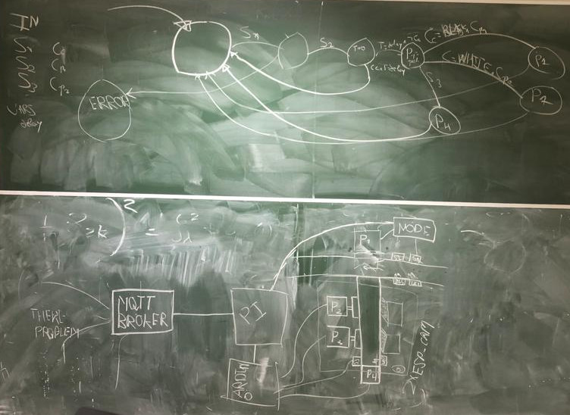

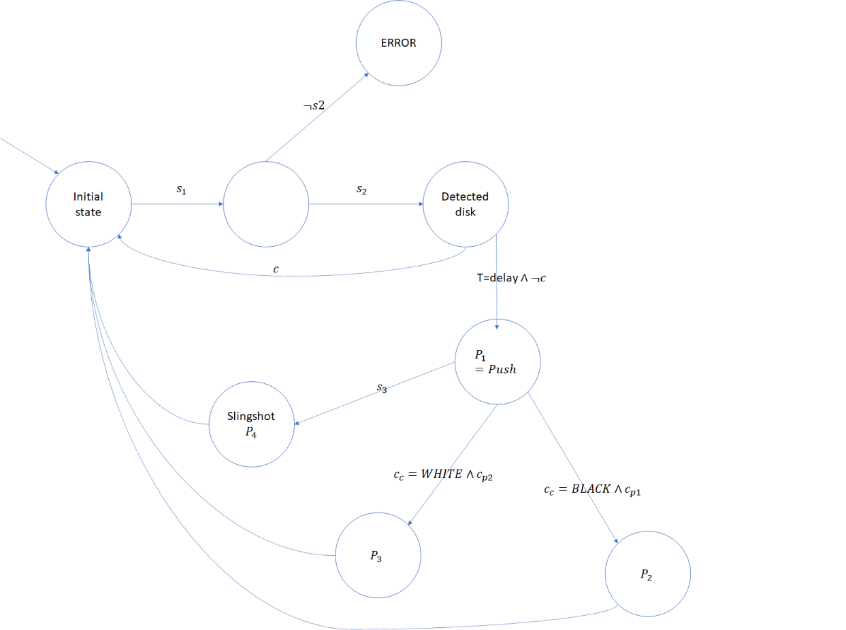

## Introducing a second board

After we had finally finalized the design of the robot in theory, it was time to implement all of the movements possible on the hardware. We began with including a second board named NodeMCU V3. We successfully connected and were able to move two servo motors on it with serial communication from the controller, while simultaneously moving a servo motor independently connected to the original Arduino and detecting input from the phototransistor, all at the same time. Now we only needed to implement the phototransistor necessary for the slingshot protocol. After we had connected it, however, we quickly realized that the NodeMCU was severely miscommunicating with the connected components. Upon stripping the system down to its basic components and only attempting to spin one servo motor periodically, we discovered it was not properly handling the rotations, as it occasionally spun for more than 720 degrees, and at other times spun erratically and unpredictably. The only conclusion we could gather was that we had short circuited the processor during the wiring of the phototransistor. We proceeded to then reimplement the entire previous machine, where the “upper” part was on a new board named Devkit V1, and the Arduino board was moved for the “lower” part, since we were now informed that we cannot have our robot touch the factory floor and we needed to have the pushing arm be as light as possible, so it can be held up by a crane arm.

## Idea for the slingshot

Now that we had surpassed that issue, we moved on to implementing all electronic parts at the same time. We had also decided that we will utilize a stepper motor and another servo for the slingshot, so we decided to attempt to implement all these elements at the same time. After we correctly wired them, being wary of any possibilities of shorting the circuit, and began moving everything the board with now two servo motors, one stepper motor and one phototransistor began rapidly being connected and disconnected and resetting. After researching, we learned that we required too many watts from that singular board. Thankfully the correction was insignificant, mainly giving the Arduino a 9 Volt power source through the VIN pin, which gives it enough power to maintain all of the objects, since USB ports are not built for it. Afterwards we successfully were able to move all motors and read all phototransistors.

We also theorized and tested appropriate designs for the slingshot. There were two significant ways to tackle the task, mainly using a solenoid or motors. Since we had already ordered a solenoid, we began experimenting with how strong it can launch the disks in the air. While on its own it was not able to produce an impressive push, we theorized that it could pull back rubber bands in order to “arm” a slingshot and then release them. We began testing to see if this was possible, however discovered that it simply did not produce enough force to pull back the rubber bands and we had to scrap the idea of using a solenoid, as well as file for a return of the order with TinyTronics.

Afterwards the only clear choice in design was translating rotational motion into potential energy big enough for the object to fly a significant distance. The best way to create potential energy on this small scale is through a spring, and in order to ensure we can fully arm the spring, we decided to utilize a stepper motor, which has a full range of motion that can be controlled somewhat accurately. The detailed movements of the servo are not needed for this arming mechanism. To hold the arm in place we also decided on using a servo to act as a simple guard that can rotate to then release an arm of some kind attached to the armed spring, launching the object held by the slingshot mechanism.

## Constructing the robot with Fischertechnic parts

Now that the designing of our robot and the electrical part of it were working, we could finally move on towards the creation and finalization of it through fischertechnik parts. While we had been working with a belt, we felt it was quite small. In our design the disks would enter the conveyer from the side, and there would be two plates to act as “gates” that would sort black and white disks. For each of those three functions we would need to occupy at least 4 cm of length of the conveyer, which was problematic since the one we were using was much shorter. This meant we had to disassemble everything we had built and recreate it but longer. After doing so, we adjusted its height as well to match our measurements of the height of the factory floor and its ramp. Additionally, after inspecting  the factory floor we learned new techniques for tightening of the belt, such as attaching a wheel on its underside to stretch it downwards, as well as for making it run slower without the use of a transistor, mainly through perpendicular gear interaction, and we then proceeded to implement those into the finalized version of our robot as well.

## Improving the serial communication

While we were working with the Serial communication throughout the entire process we began to see that there were things that could be optimized with the communication, mainly things that would allow for precise commands given from the Pi and that would be done through Serial.parseInt() in the Arduino, which would allow us to read the number that follows a command so it executes the exact given number rather than a predetermined action hard-coded into the Arduino. For this we give commands such as “P180” where it reads for the letter P and then writes 180 to the servo motor attached to the Devkit, where the number could be any number we would want to give from the Pi. This allows us for proper parameters that are controllable through the python code of our robot.

## 3D printing

What we had to do now was to find ways to connect the motors to the fischertechnik parts, as well as our cameras. While we could try to fit them in appropriately sized boxes made of various fischertechnik parts, not only is it not robust, but it also limits us in what we can build, since we will utilize very many parts in this scenario. For this reason we utilized models from the library of [Juh](https://www.thingiverse.com/juh/designs) for the servo and stepper motors, and we measured out, designed, and used his design for pins to create a holder for our ESP-32 cameras. Afterwards we fitted everything inside its connector and attached it to our robot at appropriate places, where it was more challenging to suspend the cameras, since we needed them about 30 cm above the ground.

We then implemented the gates and added a ramp for the disks to fall down further after being sorted.

## Second factory floor inspection

On the second factory floor inspection, we found out that the belt of our robot is higher than the ramp attached to the belt of the factory, so we had to shorten the robot. We restructured the entirety of the robot and fitted the arm to be lower but longer away from the robot. We attempted to build the support system close to that of a construction crane but also tried to keep supports out of the view of the cameras so that they could properly look at the conveyor belt. After we had properly secured everything, including the servo through the use of the 3D-printed parts, we began to build more quality-of-life features, such as barriers and rails and options for cables to pass through. This is where the choice of two arduino boards became apparent to be a great one, as it was much easier to transport the smaller arduino to the end of the arm where all the cables of the different motors and sensors would be connected at a short distance and then it would simply need to be connected to the RaspberryPi through one cable.

## Slingshot

Additionally we finally received the parts we needed for the slingshot and began building it. We utilized the longest parts from the fischertechnik set we were given for the arm of the slingshot and an axel to make sure it spins well. We utilized a hook part to be able to hold the rubber band and glued the other end of it to the stepper motor spinner. We then attached everything to the arduino, changed the code, and it worked without a problem. We also tested how far it launches the objects, and while it was significant, we are looking to make it go even farther for the demo.

## Finalizing the robot

In the final sprint we wanted to focus on cleaning everything up, making it more sturdy and ensuring our wires are mostly soldered to a perfboard to ensure sturdiness. For this we made use of the soldering tables in the Innovation Space in Matrix. It was the first time we had soldered anything but we prepared well with research beforehand and avoided any injuries and inhaling of toxic fumes. We created plates on which the Arduino and Devkit to go over and ports for all of the motors and sensors between the corresponding pins and then soldered them together appropriately, testing with each of them once we were finished. There were some issues with the soldering, like there being too much material in one place but we also utilized the desoldering tool that the Innovation Space provides to remove such faults. We also found difficulties that had not popped up before regarding the motors and phototransistors of the Devkit, but we decided to fix them by using the 5V current from the Arduino (as well as its Ground) as the new power source for the motors and sensors, which also meant we needed to solder two longer wires onto the board with the purpose of reaching the place where the Devkit will stand from the Arduino.

Additionally after doing testing in multiple environments, we came to the conclusion that there could be lighting conditions under which our cameras would not be able to detect the black circles because of the aperture of the cameras and possible lens flares. For this we needed to set up some more reliable lighting and since we had finalized our wiring, we thought that it would be much easier to use a store-bought torch to illuminate the belt better on the day of the demo market or beforehand. Only one did not seem to be enough however, as the shadow it creates on the other side of the objects bring similar problems as before, so we set up two flashlights on two different ends of the active area that also did not block the cameras’ views of the belt.After the added weight we need to add more supports and in the end it became sturdy enough where the only way for it to break would be to apply more force to the robot than is needed to disconnected two fischertechnik parts, so we could deduce that it is enough.

On the third belt inspection, however, we noticed that the pusher was still one fischertechnik block too tall and we had to think of ways to affect it lower without changing everything about the robot, so we used the already existing pusher and attached to its end a a pusher head at the correct height and moved the LEDs and phototransistors to the desired locations

Afterwards we tested everything for a final time and while issues popped up with the gluing of certain parts, everything responded and sent data correctly and thus we concluded with the development of the physical robot.